The Grove Nursery
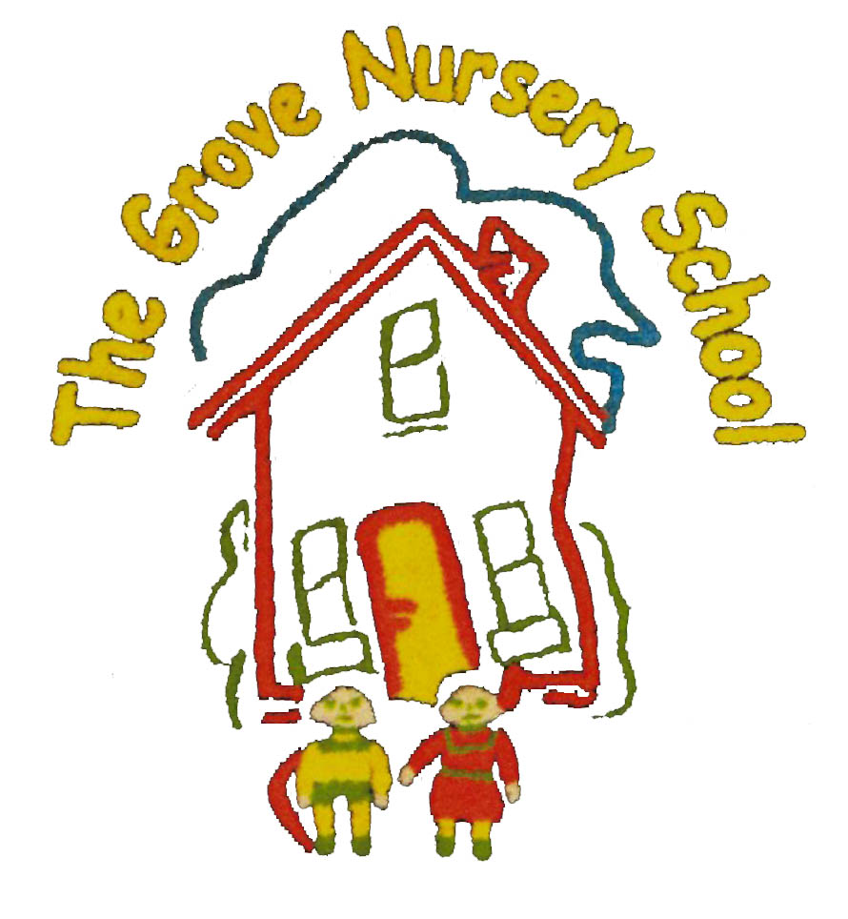
Easter Update 2024
* We have planted our potatoes and herbs, are looking forward to warmer weather when we will plant more tender vegetables. We are also planting beans or peas and will be sending these home for the children to notice signs of ‘growth’ over the holidays. Alex (and his Dad) has brought in a real Lamb, called Little Bo Peep. Thank You!
*We are really enjoying the numerous ‘storytelling’ guests and every child will take part in at least one session with a visiting Principal from a local school. Check out our website to see who our visitors are. These visits will continue after Easter.
* School will close on Wednesday 27th of April @ 11.30 a.m. for the Easter Holidays. On that day we will have an Easter Egg Hunt. No need to send a packed lunch and dinners are not available!

* School will re-open on Tuesday, 9th April 2021 @ 8.45 - 9.00 a.m. Please try to have your child in on time as we aim to be outdoors immediately in the morning, and as all staff members are outside on duty, we may not hear the bell. We also have a visit planned that morning from the Community PSNI who will be sharing aspects of Road Safety/Stranger Danger etc. and allowing the children to learn more about the role of a policeman/woman on the theme of ‘People Who Help’.

*Would any Mum appreciate the gift of a slow cooker and ingredients to make two meals for 4 weeks ?
This initiative is offered by Friends Of The Folly River, and held on Tuesday 9th April from 7.00-9.00 p.m in our school. The next three weeks are done via Zoom – an excellent scheme and an opportunity to meet other mums. Places are limited, so speak to Mrs Thompson a s a p. Harvey W and William’s Mum attended the last class- so speak to them to see what is expected. The only requirement is that you have a child under 12 years.

*After Easter, as the weather improves, girls may wear red or blue summer dresses, maybe with shorts or leggings underneath and boys can opt for shorts, if they wish. Watch out for skinned knees! Do remember that open toed sandals are dangerous during outdoor play and should not be worn.

* We are planning to participate in Rugby Tots w/c 8/4 (Thursdays). Children will be taught outside by Justin with a staff member, in a small group of 12-13 children. This is one of the highlights of every year. Please complete a permission form and enclose £12 for a six week course, on return to school after Easter. Your child can not participate without this. Normally the cost would be much higher but school has some money from last year’s School Sponsored Walk to offset some of the cost.

Have a lovely Easter and keep safe! Don’t eat too many eggs!

