The Grove Nursery School
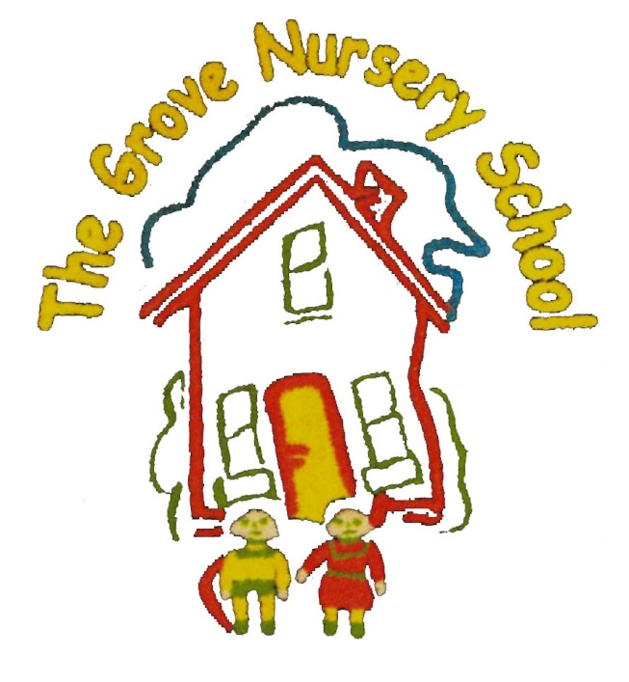
Holiday/Closure List 2023/2024

Monday 30th October to Friday 3rd November (Inclusive) =Hallowe’en Holiday (5 days) Schools ends with Harvest Hoedown, 11.30 a.m. on Friday 27th October No school meals (Staff & Parents will Provide ‘A Cowboy Brunch’)
After Hallowe’en, School Day extended to 1.15 p.m.= Monday 6th Nov.2023

Thursday 21st School Ends @ 11.30 a.m. (Class Christmas Party)
Friday 22nd to Friday Jan 5th 2024 = Christmas Holidays & SD Day 1 (11 days)
Winter Term Begins on Monday 8th January @ 8.45 a.m.
Friday 9th Feb School ends @ 11.30 a.m.
Monday 12th to Friday 16th Feb = Half Term (5 days)
Monday 18th & Tuesday 19th March = St Patricks Day & SD Day 2 (2 days)
Wednesday 27th March School ends @ 11.30 ‘Easter Eggstravanza’
Thursday 28th to Monday 8thApril = Easter Holidays & SD Day 3 (8 Days)

Summer Term begins on Tuesday 9th April 2024 @ 8.45 a.m.
Monday 6th May = May Bank Holiday (1 day)
Monday 27th May (1 day)
School ends for Summer on Thursday 27th June @ 11.30 a.m.

Still 1 SD Day to be confirmed.
On Early Closure Days, children can wear their own normal, Party, or Dressing Up clothes, if they wish or School Uniform.

