K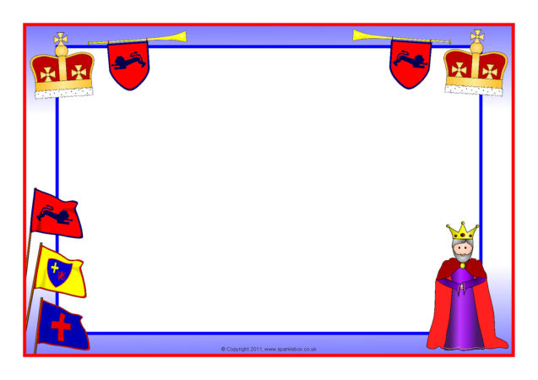

King Charles Coronation Garden Party Menu Friday 5th May 2023

Crisps & Cocktail Sausages

A selection Of ‘Royal’ Sandwiches – JAM, HAM & CHEESE

‘The Sweet Table’ - Royal Cupcakes

Royal Biscuits

Royal Tophats/ Chocolate Crispies

‘For Afters’ - Jelly, Wafers & Ice Cream

‘From The Drinks Trolley’ – Water, Milk, Orange & Raspberry Juice

Served in The Unique Royal Style Of The Grove by our lovely Mums!

To the Music of Killylea Silver Band