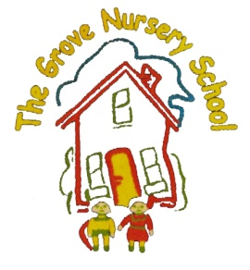 THE GROVE NURSERY SCHOOL C:\Users\Ivan\AppData\Local\Microsoft\Windows\Temporary Internet Files\Content.IE5\N32Q5PDU\MC900233040[1].wmf

‘Spring’ Rhymes and Songs

WE ARE GOING TO PLANT A BEAN (Action Song) Tune=Here we go round Mulbury Bush

C:\Users\Ivan\AppData\Local\Microsoft\Windows\Temporary Internet Files\Content.IE5\WPLR2FTE\MC900059136[1].wmf

We are going to plant a bean,

Plant a bean, plant a bean.

We are going to plant a bean,

In our little garden.

First we plant it with our finger,

With our finger, with our finger.

First we plant it with our finger,

In our little garden.

Then the summer sun will shine,

Sun will shine, sun will shine.

Then the summer sun will shine,

In our little garden.

Then the raindrops, they will fall,

They will fall, they will fall.

Then the raindrops, they will fall,

In our little garden.

Then the little bean will grow,

Bean will grow, bean will grow.

Then the little bean will grow,

In our little garden.

5 LITTLE PEAS

C:\Users\Ivan\AppData\Local\Microsoft\Windows\Temporary Internet Files\Content.IE5\N32Q5PDU\MC900336101[1].wmf

5 little peas in a pea pod pressed.

One grew, two grew, and so did all the rest.

They grew and grew and did not stop,

Until one day the pod went POP !

OATS & BEANS & BARLEY

C:\Users\Ivan\AppData\Local\Microsoft\Windows\Temporary Internet Files\Content.IE5\73V8A5BR\MC900334122[1].wmf Oats and beans and barley grow,

Oats and beans and barley grow,

You, nor I, nor nobody knows,

How oats and beans and barley grow.

First the farmer sows his seed,

Then he stands and takes his ease,

Stamps his feet and claps his hands,

And turns around to view the land.

SEEDS (poem)

Five small seeds planted in a row.

Down came the rain.

The seeds began to grow.

Out came the sun,

The buds began to show.

Five small flowers growing in a row.

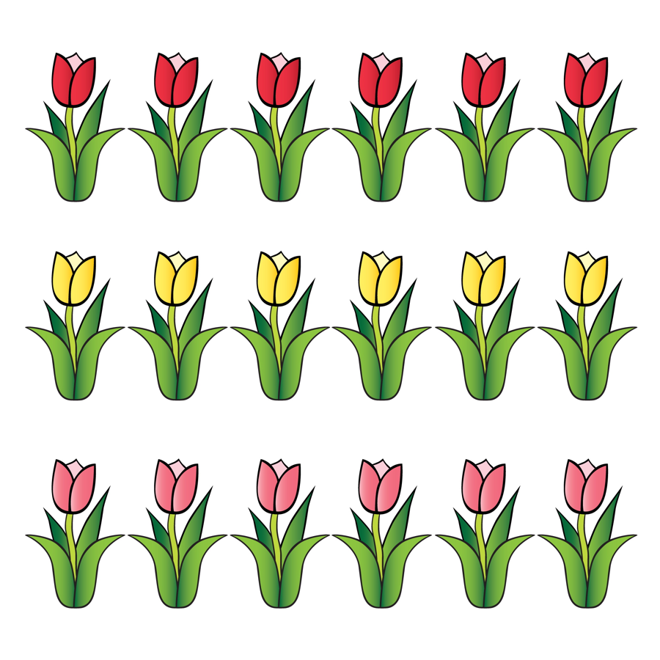

5 LITTLE SEEDS

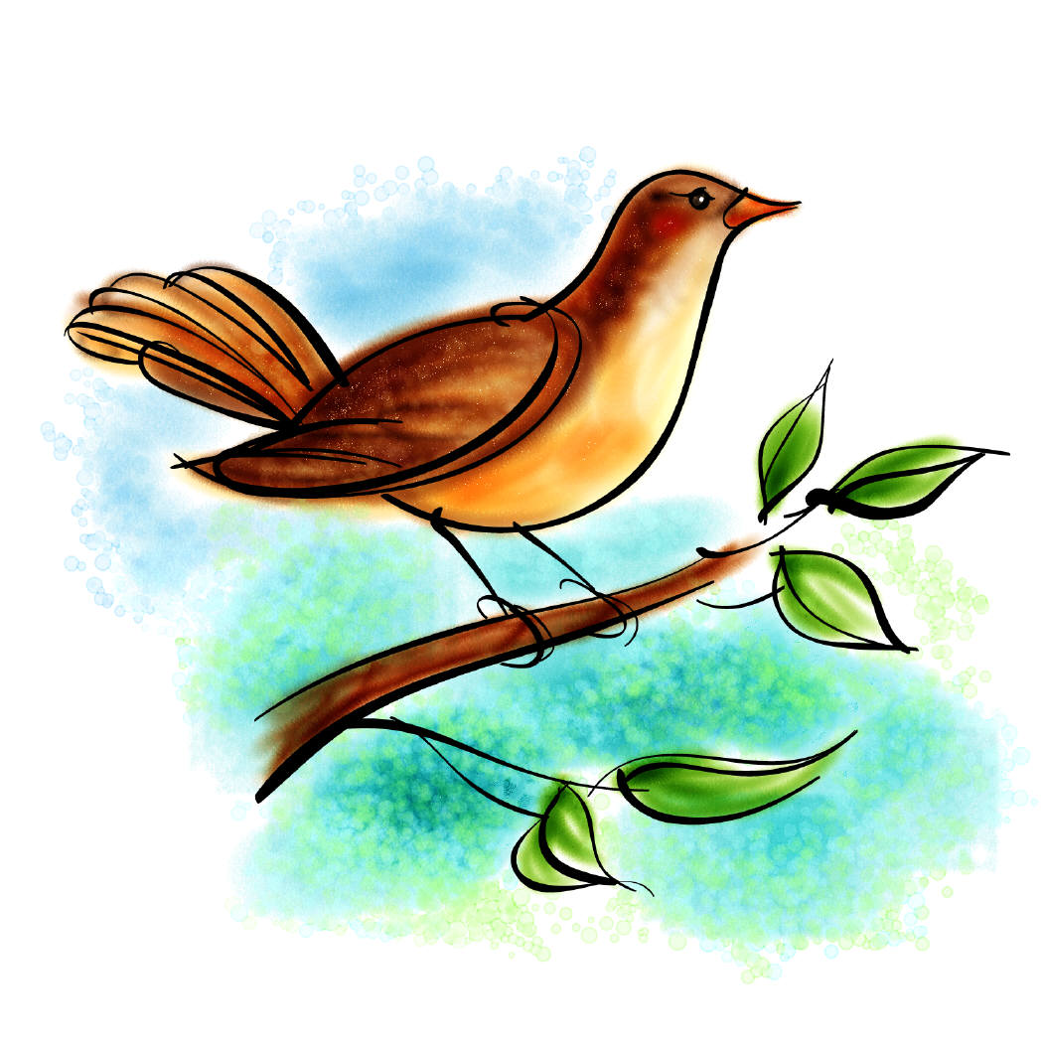

5 little seeds, a sleeping they lay,

A bird flew down

And took one away.

How many seeds were left that day?

4 little seeds....etc. (Use fingers to help counting down)

THE BIRDS IN THE TREES (Tune = Wheels on the Bus)

C:\Users\Ivan\AppData\Local\Microsoft\Windows\Temporary Internet Files\Content.IE5\NT3IN3FD\MC900285582[1].wmf

The birds in the trees, they sing out loud,

Sing out loud, sing out loud.

The birds in the trees, they sing out loud

‘Cause Spring is here.

The lambs in the fields – they skip and jump.

The chicks in the eggs- all peck right out.

The rabbits down the holes – pop in and out.

C:\Users\Ivan\AppData\Local\Microsoft\Windows\Temporary Internet Files\Content.IE5\WPLR2FTE\MC900331609[1].wmf

CHICK,CHICK. CHICK,CHICK, CHICKEN

Chick, chick, chick, chick, chicken, lay a little egg for me.

Chick, chick, chick, chick, chicken, I want one for my tea.

I haven’t had an egg since breakfast

And now it’s half past three.

So, chick, chick, chick, chick, chicken, lay a little egg for me.

5 LITTLE DUCKS

5 little ducks went swimming one day,

Over the pond and far away.

C:\Users\Ivan\AppData\Local\Microsoft\Windows\Temporary Internet Files\Content.IE5\N32Q5PDU\MC900355057[1].wmf

Mama Duck said “Quack quack, quack quack.”

But only 4 little ducks came back.

4 little ducks..........etc.

C:\Users\Ivan\AppData\Local\Microsoft\Windows\Temporary Internet Files\Content.IE5\NT3IN3FD\MC900090985[1].wmf 6 LITTLE DUCKS

6 little ducks that I once knew,

Fat ones, skinny ones, tall ones too.

But the one little duck with the feathers at the back,

He ruled the others with a “Quack, quack, quack”!

He ruled the others with a “Quack, quack, quack”!

LITTLE TOMMY TADPOLE

Little Tommy Tadpole began to weep and wail,

Because little Tommy Tadpole had lost his little tail.

His mother did not know him, as he sat upon a log,

C:\Users\Ivan\AppData\Local\Microsoft\Windows\Temporary Internet Files\Content.IE5\WPLR2FTE\MC900356163[1].wmf

Because Little Tommy Tadpole was now Mr. Thomas Frog !

C:\Users\Ivan\AppData\Local\Microsoft\Windows\Temporary Internet Files\Content.IE5\N32Q5PDU\MC900329589[1].wmf

5 LITTLE SPECKLED FROGS

5 little speckled frogs sat on a speckled log,

Eating some most delicious bugs. Yum, yum.

One dived into the pool, where it was nice and cool.

Now there are 4 green speckled frogs. Croak, croak.

4 little speckled frogs......etc.

C:\Users\Ivan\AppData\Local\Microsoft\Windows\Temporary Internet Files\Content.IE5\N32Q5PDU\MC900022276[1].wmf 5 G

C:\Users\Ivan\AppData\Local\Microsoft\Windows\Temporary Internet Files\Content.IE5\N32Q5PDU\MC900022276[1].wmfC:\Users\Ivan\AppData\Local\Microsoft\Windows\Temporary Internet Files\Content.IE5\N32Q5PDU\MC900022276[1].wmfC:\Users\Ivan\AppData\Local\Microsoft\Windows\Temporary Internet Files\Content.IE5\N32Q5PDU\MC900022276[1].wmfC:\Users\Ivan\AppData\Local\Microsoft\Windows\Temporary Internet Files\Content.IE5\N32Q5PDU\MC900022276[1].wmf

5 GREEN LEAVES

C:\Users\Ivan\AppData\Local\Microsoft\Windows\Temporary Internet Files\Content.IE5\N32Q5PDU\MC900434575[1].wmf

5 green leaves, high up in the trees,

5 green leaves, swaying in the breeze.

Along came a caterpillar looking for his lunch,

Gobbled up the first leaf.

Munch. Munch. Munch !

4 green leaves, high up in the trees,

... gobbled up the next leaf.

Munch. Munch. Munch.

C:\Users\Ivan\AppData\Local\Microsoft\Windows\Temporary Internet Files\Content.IE5\N32Q5PDU\MC900391464[1].wmf

THE SUNFLOWER SONG (Tune = I’m a little Teapot)

I’m a yellow sunflower, strong and tall.

See my petals, see my stalk.

When I see the sunshine, I will grow.

Taller and taller and taller I go.

C:\Users\Ivan\AppData\Local\Microsoft\Windows\Temporary Internet Files\Content.IE5\WPLR2FTE\MC900304933[1].wmf

EASTER BUNNY

Easter Bunny, soft and white,

Hopping quickly out of sight.

Thank You for the eggs you bring.

At Easter time we welcome Spring.

Easter Bunny, soft and white.

Hopping quickly out of sight.

C:\Users\Ivan\AppData\Local\Microsoft\Windows\Temporary Internet Files\Content.IE5\N32Q5PDU\MC900128719[1].wmf

B.I.N.G.O.

There was a farmer had a dog,

And his name was Bingo.

B.I.N.G.O.

B.I.N.G.O.

B.I.N.G.O.

And Bingo was his name. Oh !