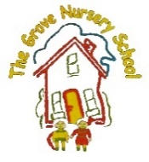 Baby Bill Owl said “I Want…. To Shop!”-
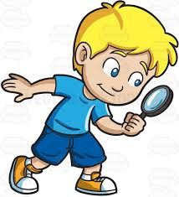
He knows that there are lovely shops in Armagh and maybe that’s where his Mummy is?
As you already know, in The Grove, we love listening to and reading stories. We have ‘targeted’ stories every month. These are some stories that the children enjoy hearing again and again, act out by dressing up as characters, retell using props or puppets, sequence events in the story using laminated pictures, represent using art materials, ’read’ the stories independently, or simply join in with familiar phrases.
We are sure that you have noticed the displays based around such favourite stories and perhaps you have even borrowed the books from school, to read at Bedtime.
One of our favourite stories is about 3 Little Owl Babies whose Mummy has left them alone (in The Folly?) and Bill, the youngest says something we said in school in September – certainly not now!! “I want my Mummy!”
This year, we are really excited to invite the children, parents and friends to go on an ‘Owl Hunt’ around Armagh, looking for the 3 main character in the local shops- either in the window or on a counter. This is not only a fun activity that the whole family can get involved in but also promotes observational skills, when out and about and encourages a greater interest in early literature. Children can count ‘how many’ sets of Owl Babies they have found or still have to find and the strenuous exercise walking up Scotch Street is beneficial!!
Thank You to all the local traders who facilitated this idea, were brave enough to host a ‘Family of Owls’ and to welcome all our participants in the ‘Owl Babies Hunt’. Please support them with your custom in the run up to Christmas! The owls will move on to The Folly at the beginning of December, so start hunting soon!
