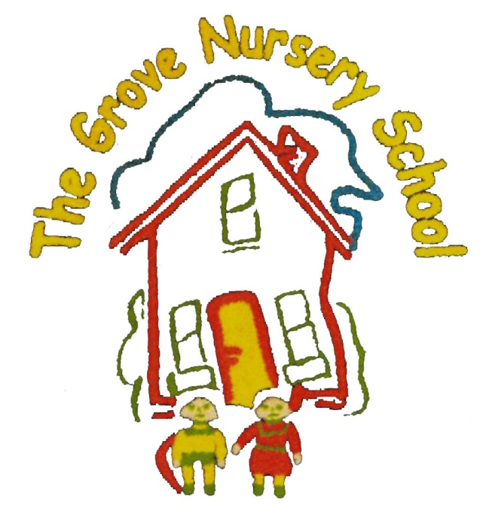

The Grove Nursery School

‘Healthy Me’ Rhymes & Songs

**BRUSH, BRUSH, BRUSH YOUR TEETH**

**( Tune = ‘Row, Row, Row Your Boat’)**

Brush, brush, brush your teeth.

C:\Users\Ivan\AppData\Local\Microsoft\Windows\Temporary Internet Files\Content.IE5\EOHBFJVF\MM900283916[2].gif

Use some toothpaste too.

Brush up and down and all around

And eat what’s good for you.

Brush, brush, brush your teeth,

Round and round and round.

Brushing, brushing, brushing, brushing-

What a lovely sound!

**WASH YOUR DIRTY HANDS**

Wash your dirty hands.

Wash your dirty hands.

Rub and scrub and



Rub and scrub.

And wash your dirty hands.

* Wash your dirty feet……etc.
* Wash your dirty knees…
* Wash your dirty tummy……
* Wash your dirty back….
* Wash your dirty arms…
* Wash your dirty face…..
* Wash your dirty neck….
* Wash your dirty hair…..

**WASHING HANDS SONG ( Tune = ‘Frere Jacques’)**



Soap and water, soap and water.

Wash your hands, wash your hands.

Rub them well together.

Rub them well together.

Rinse them well. Rinse them well.

**THIS IS THE WAY (Tune = ‘Mulbury Bush’)**

This is the way we wash our hands,

Wash our hands, wash our hands.

This is the way we wash our hands,

In our Nursery School.

**MY TOOTHBRUSH (Poem)**

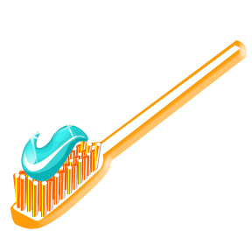

I have a little toothbrush.

I hold it very tight.

I brush my teeth each morning,

And then again at night.

**TEDDY GOES TO BED (poem)**

C:\Users\Ivan\AppData\Local\Microsoft\Windows\Temporary Internet Files\Content.IE5\0VRO9G7S\MC900232911[1].wmf

Ready teddy? Time for bed !

But naughty Teddy shook his head.

Ran and hid behind a chair.

Thought I wouldn’t find him there. But I did!

So I took him up the stairs,

Listened as he said his prayers.

Tucked him in. Turned off the light.

Kissed him twice (kiss, kiss)

And said “Good Night”

**We’re Getting Lots of Exercise**

**(Tune = ‘The Farmer Wants A Wife’)**

‘



We’re jumping up and down.

We’re jumping up and down.

We’re getting lots of exercise.

We’re jumping up and down.

Other verses

* We bend and touch our toes…
* We stretch up to the sky…
* We wave from side to side…

**BARNEY SONG**

**'I LOVE YOU’**

I love you. You love me.

We’re a happy family.

With a great big hug and a kiss

from me to you,

Won’t you say you love me too?

I love you. You love me.

We’re best friends like

friends should be.

With a great big hug and a kiss

from me to you,

Won’t you say you love me too?

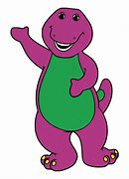

**HANDS ON HIPS (Action poem)**

Hands on hips,

Hands on knees.

Hands behind you

If you please.

Touch your shoulders.

Touch your toes.

Touch your knees,

And touch your nose.

**VEGETABLES** (POEM)

Slicing up the carrots

Ready for the pot.

Up and down the knife goes

Chop! Chop! Chop!

Scrubbing the potatoes,

Cleaning off the mud.

To and fro the brush goes.

Scrub! Scrub! Scrub!



**HEAD AND SHOULDERS, KNEES AND TOES**

C:\Users\Ivan\AppData\Local\Microsoft\Windows\Temporary Internet Files\Content.IE5\0VRO9G7S\MC900232431[1].wmf

Head and shoulders, knees and toes,

Knees and toes,

Head and shoulders, knees and toes.

Knees and toes.

And eyes and ears and mouth and nose.

Head and shoulders, knees and toes.

Knees and toes.

Each time you sing, try leaving out a body part by touching it,

but not singing it out loud!

**HOLD MUM’S HAND (Tune = ‘3 Blind Mice’)**



Hold Mum’s hand. Hold mum’s hand.

To cross the road. To cross the road.

Stop and look and listen with care.

Of the traffic you must beware.

So hold mum’s hand. Hold mum’s hand.

**WHEN CHILDREN TRAVEL IN THE CAR**

**(Tune = ‘Old MacDonald’)**

When children travel in the car, what must they do ?

They must sit in the back seat and be strapped in too.

With a toot toot here and a toot toot there.

Here a toot, there a toot,

C:\Users\Ivan\AppData\Local\Microsoft\Windows\Temporary Internet Files\Content.IE5\F6GYQ0X4\MC900419350[1].wmf

Everywhere a toot toot.

You must sit in the back seat.

I must sit there too.