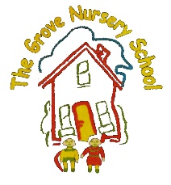 The Grove Nursery School Home/School Links October Topic = ‘Autumn’
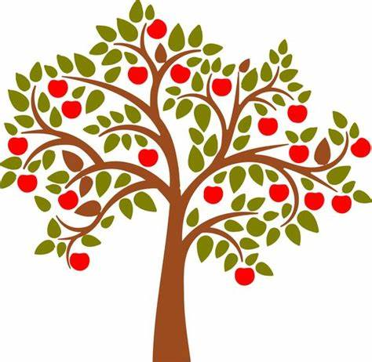
Personal, Social &  Emotional Development-  How we & others feel! | - What makes you happy? sad? scared? etc. Can you show me a happy/sad/scared/ excited face etc.?  - Practise washing your hands to keep the Covid germs away. Sing our special hand washing song.  - Do something to make someone happy e.g. tidy up, draw a picture, sing a song, give a hug, put on your coat.
Early Mathematical  Experiences-  Shapes, colours, patterns, counting, numbers | - Sort leaves by colour and size. Use language such as ‘big’ ‘smaller’ ‘long’. How many red? Put in a line and count 1:1.  - Cut out some small shapes and stick onto a page to make a picture e.g. an owl with Ο eyes & a Δ nose.  - Put some conkers/acorns/ cones into an egg box/tray. How many can you count?
Language & Communication-  Stories, Songs, Rhymes, Mark Making and Literacy | - Read stories about Woodland Animals. How many can you name?–badger, hedgehog, owl, mole, fox, squirrel, rabbit etc.  - Refer to our song/rhyme sheet. Don’t forget to do the actions too.  - Draw ‘spikes’ on to a hedgehog shape to make him prickly.
Physical Development-  Gross and Fine Motor Skills  Inside and outdoors! | - Throw leaves in the air and try to catch them. Kick up the leaves, stamp on them. What sound do they make?  - Dance with scarves. Twirl like falling leaves. Can you use your fingers like the falling leaves?  - Use a brush to make a pile of leaves. Can you find a wheelbarrow and push?  - Use scissors to snip straws or to ‘cut into’ a ball of dough. Adult supervision needed here!
Creative Development-  ,’The Arts’- drawing, painting, acting, role play, dough, junk art, dancing | - Push cocktail sticks into chestnuts to make a hedgehog. Why don’t you make a family and hide under leaves?  - Make some ‘new’ colours by mixing paint e.g. red and yellow, blue and green. Can you make orange or brown?  - Practise ‘scampering’ like a squirrel, rolling up (hedgehog), jumping (rabbit) flying & swooping (owl).
The World Around Us-  Nature, Seasons, Science & Technology, The Past, Animals, Other lands | - Go on a walk. Notice the different coloured leaves. What else can you find?-acorns, fir cones, berries, apples, conkers? Make a collection on a plate.  - Find out about the different animals that live in the wood. Some of them ‘hibernate’-others are ‘nocturnal’. What do these words mean?  - The birds are hungry. Put out some crumbs and see who visits. Can you see a red robin?

